KubeRay
Official documentation: docs.ray.io.
KubeRay is Kubernetes operator enabling running Ray on Kubernetes.
It provides 3 CRDs:
- RayCluster – Used to create a Ray cluster
- RayJob – Used to run batch jobs on a Ray cluster
- RayService – Used to create a Ray cluster and run on it Ray Serve apps

RayService
RayService can be used to create a Ray cluster (Head and Worker Pods) and run on it Ray Serve apps.
It deploys a proxy (HTTP gateway, Starlette ASGI) on the Head Pod by default.
This proxy receives clients requests and forwards them to a proper Actor replica.
We can also create multiple proxy replicas and then some of them will run on Worker Pods as well.

YAML configuration
If we have for example a Ray Serve app like this:
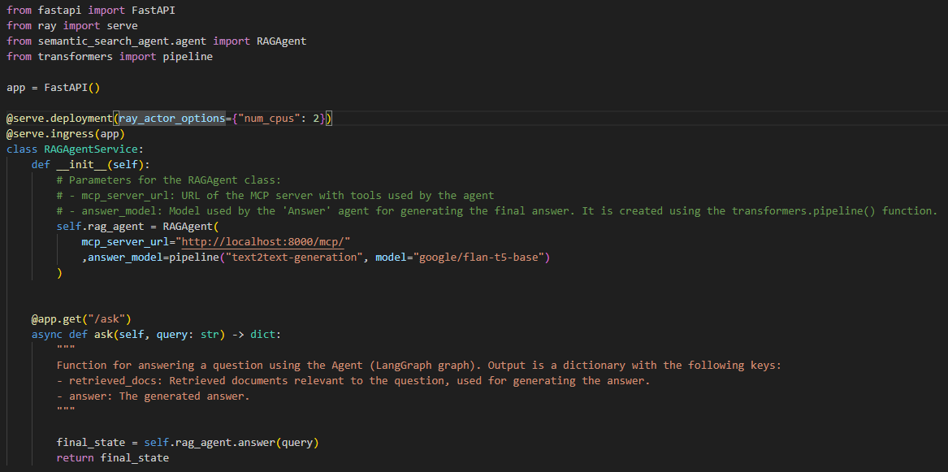
And it is saved as /app/ray_serve_app.zip, then a YAML manifest for RayService will look like this (below are 3 screenshots of the same YAML file):
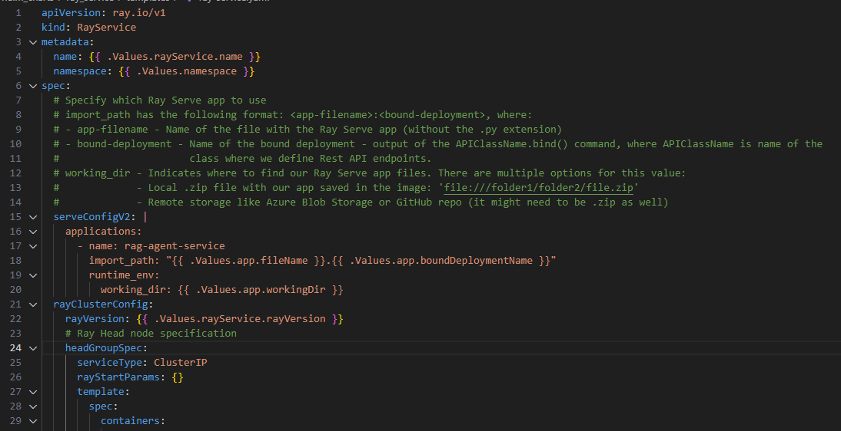
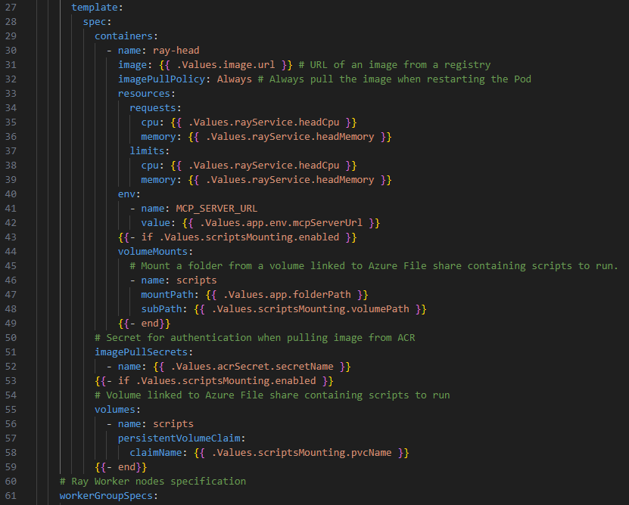
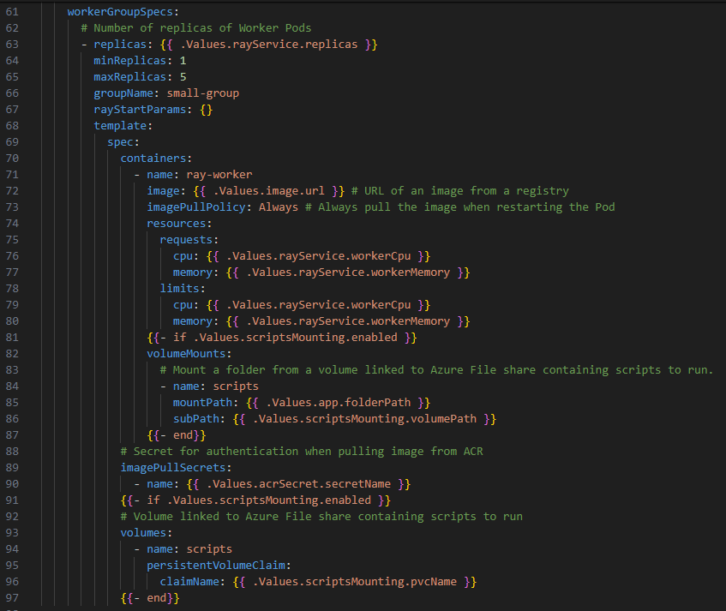
Here we specify number of replicas of Worker Pods, not Actors. Number of Actors replicas is specified in the Python script with defined Ray Serve app.
I think that our app needs to be save as a .zip file.

Installing RayService – flow of events
Here are the steps followed to install RayService CRD:
- RayService CRD (YAML) is applied
- KubeRay operator submits a Ray Job to the head node
  - That job is called Serve driver. It runs in its own pod or in the head pod. It is a Python process that imports our file with Ray Serve app and runs the bound deployment.
  - Import_path parameter from the RayService CRD is used by the KubeRay and Serve driver.
  - For example if our RayService has this configuration:
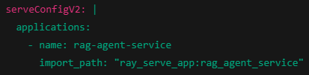
And our Ray Serve app looks like this:
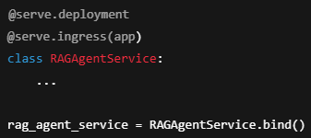
Then Serve driver will run internally something like:
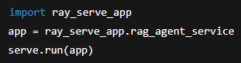
- Serve driver connects to the Ray cluster, launches the ServeController, and registers our deployment(s).
- Once the Serve driver is running, we will see logs like ray_serve_controller.out under /tmp/ray/session_latest/logs/.

